1. The integration of artificial intelligence in medical imaging practice: Perspectives of African radiographers

* Bias:
  + Survey targets only African radiographers instead of considering the radiological community as a whole.
* Size: 1020
* Confidence interval: 95%
* Demographics:
  + 69.6% male.
  + Age 20-29 37.8%, 30-39 38%.
  + From 28 African countries, mostly Nigeria.
  + Only 6.3% of the participants have competent programming skills. 61.3% understand the basic concept. The rest not at all.
* Results:
  + 84.9% believe that AI will improve radiological practice.
  + 61.3% think AI will take African radiographers’ jobs.
  + 76.4% think AI will change the role of radiographers leading on to extended practices.
  + 92.5% require further training for them to fit in this trend.
* Correlations (Spearman's rank-order):
  + Significant positive correlation between attitude toward AI and age. rs = 0.83, P = 0.008.
  + Significant positive correlation between attitude toward AI and year of practice. rs = 0.108, P = 0.001.
  + No significant correlation between attitude toward AI and education level. rs = 0.60, P = 0.345.
  + Significant correlation between opinion on job security and age. rs = 0.136, P = 0.001.
  + Significant correlation between opinion on job security and age. rs = 0.154, P = 0.01.
  + Significant correlation between opinion on job security and age. rs = 0.209, P = 0.001.

1. Modeling adoption of intelligent agents in medical imaging

* Bias:
  + Small sample size.
  + Race and ethnicity not recorded.
* Size: 322.
* Confidential interval: Not mentioned. 95%?
* Demographics:
  + Mostly from the USA/Canada 25.5%. Internationally.
  + 59.9% men.
  + 65.2% have more than 10 years of experience.
* Results:
  + 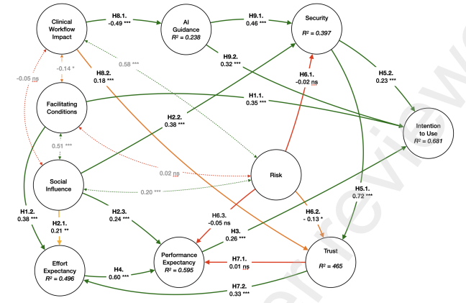
  + Facilitating conditions are positively predicting the intention to use AI.
  + Facilitating conditions and effort expectancy significantly related.
  + Social influence impacts performance expectancy, effort expectancy, and security.
  + Performance expectancy positively affects Intention.
  + Performance expectancy positively affects effort expectancy.
  + Security positively affects trust.
  + AI guidance impacts both security and intention Significantly.
  + Clinical workflow impact has a negative impact in AI guidance, but a positive impact on trust.
  + Demographic factors like age, gender, region cause different opinions.
* Recommendations:
  + AI guidance and clinical workflow impact are important when it comes to implementation.
  + AI systems should consider demographics.
  + AI systems should treat different medical cases differently, more personalized.
  + The design should enhance usability and functionality of the system, improve security and trust, and reduce risk.

1. Introduction of human-centric AI assistant to aid radiologists for multimodal breast image classification

* Bias:
  + Only in Portugal.
  + Small sample size.
  + Only targeting breast imaging.
* Size: 45.
* Confidential interval: Not mentioned, 95%?
* Demographics:
  + From the same hospital.
  + 24.4% have 31-40 years of experience, 31.1% have 11-20 years of experience, 26.7 are interns.
* Results:
  + Different medical experience groups demonstrate different scoring regarding assistance set up.
  + 69% acceptance with assistance VS 22% current situation.
  + 82% think the assistants were well implemented.
  + 80% confidence level with assistant.
  + 86% disagree the system is unnecessarily complex.
  + 83% disagree on the current system.
  + The assistant condition improved SUS items for total disagreement by 86%.
* Insight:
  + Workflow recognition is important.
  + Evidence should be provided to the clients.

1. Investigating the impacting factors for the healthcare professionals to adopt artificial intelligence-based medical diagnosis support system (ASMDSS)

* Bias:
  + Only Chinese radiologists.
  + Small sample size.
  + Potential moderators not taken into consideration.
* Size: 191
* Confidential interval: Not mentioned, 95%?
* Demographics:
  + 62.82 Female.
  + Mainly under 40 years old, under 15 years of working experience.
  + 91.11% medical imaging department.
* Result:
  + 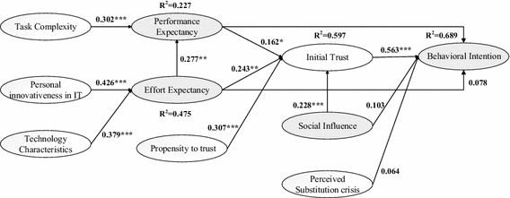
  + Task complexity positively affects performance expectancy.
  + Personal innovativeness in IT impacts effort expectancy significantly.
  + Technology characteristics impact effort expectancy significantly.
  + Effort expectancy impacts performance expectancy significantly.
  + Initial trust has a significant influence over behavioral intention.
  + Social influence impacts initial trust directly.
  + Propensity and effort expectancy to trust also impact initial trust.
* Insight:
  + It is important to gain clients’ trust.
  + Social influence is sometimes underestimated as a factor of influence.

1. The effect of machine learning explanations on user trust for automated diagnosis of COVID-19

* Bias:
  + Not to mention enough demographic information from the participants.
  + Medical imaging only aiming to diagnose COVID-19.
  + Small sample size.
* Size: 20
* Confidential interval: Not mentioned, 95%?
* Demographics:
  + Evenly distributed work experience.
* Result:
  + Doctors find AI models more helpful when no explanations are provided.
  + Weak explanations do not help the understanding of the results.
  + The specificity of the explanations does not impact the trust.
* Insight:
  + Do not try to explain the machine learning models to the radiologists.